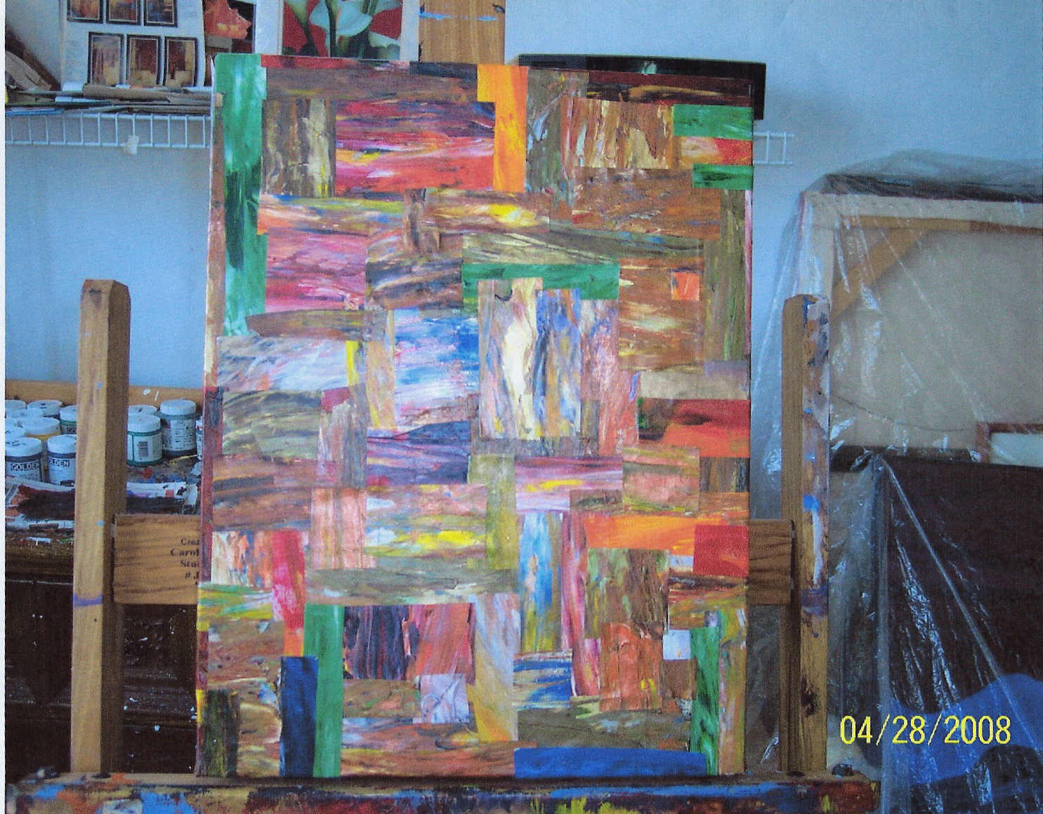
MUTINY NOW GALLERY
Presents New Artworks
By
CALVIN RILEY
MEET THE ARTIST
SAT. JUNE 7TH
1pm – 3pm
Show runs through June 30th, 2008
at
Mutiny Now Gallery
2 S. Broadway
Denver, Colorado
(Corner of Ellsworth & Broadway)
Information 303.778.7579

